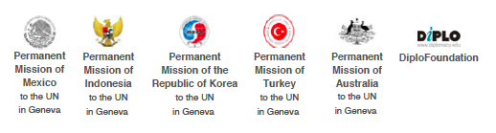

MIKTA DIPLOMACY
NEW DYNAMISM OR MORE OF THE SAME?

PANELLISTS

Geneva

29 August 2014

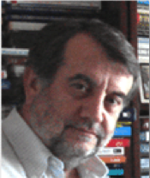
Prof. Raymond Saner is Professor Titular in Organisation and International Management (University of Basle). He is the co-founder of CSEND, a Geneva based NGRDO (non-governmental research and development organisation (since 1993) and the director of CSEND’'s Diplomacy Dialogue branch. His research and consulting focuses on international trade and development, conflict studies and international negotiations at bilateral, plurilateral and multilateral levels in the field of trade (WTO), employment and poverty reduction (ILO, PRSP), trade and development (WTO, UNCTAD, EIF), human and social capital development in the educational sector (GATS/ES/WTO and OECD) and trade, investment and climate change (UNCTAD). Raymond Saner pioneered the field of business diplomacy and contributes to the study of multi-stakeholder diplomacy within the field of diplomacy and teaches at Diplomatic Academies and Schools in Europe and North America.
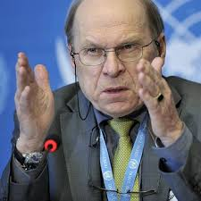
Ambassador Toni Frisch is former Head of Humanitarian Aid of the Swiss Agency for Development and Cooperation and former Deputy Director General of Swiss Development Corporation (officially retired in October 2011). He is the chair of INSARAG, Intl Search And Rescue Advisory Group and the Consultative Group of MCDA, Military And Civil Defense Assets. He is a member of Margareta Wahlströms Bureau for Sendai, where he represents WEOG countries. Ambassador Frisch is also a member of the Swiss Red Cross Board.

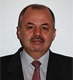
Dr Petru Dumitriu is currently Ambassador and Permanent Observer of the Council of Europe to the United Nations Office and other international organisations in Geneva. He was the representative of Romania in the Executive Board of UNESCO (2010–2011) and national coordinator of the United Nations Alliance of Civilizations (2008–2011). From 2006 till the end of 2010 he served as Director General for Multilateral Affairs and Director General for Global Affairs in the Ministry of Foreign Affairs. He was an elected member of the UN Committee on Contributions (2001–2009). He was rapporteur of the Geneva phase of the World Summit on the Information Society (2002). In 1997, he acted as Secretary-General of the Third International Conference of New and Restored Democracies. He was also vice-president of the UNICEF Executive Board (1995), the UN Commission on Disarmament (1997), and the Special Political and Decolonisation Committee (1997). His flagship books are The United Nations System in the Context of Globalization: The Reform as Will and Representation (in Romanian) and Diversité dans l’unité: La capacité de négociation de l’Union Européenne au sein de la Commission des droits de l’homme des Nations unies.

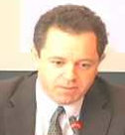
Dr Daniel Low-Beer is Visiting Fellow at the Global Health Programme, The Graduate Institute. He previously worked as Director of Performance, Impact and Effectiveness at the The Global Fund to Fight AIDS, Tuberculosis, and Malaria. He had also worked in WHO, South Africa and Cambridge University. Dr Low-Beer has published a recent book on Innovative Health Partnerships: the diplomacy of diversity (just also published in Chinese). His work with the Graduate Institute focuses on Global Health impact - how it is measured, and the governance and accountabiltiy of including impact in the post-2015 development agenda. He also taught in our course on BRICS and Global Health Diplomacy held in China this month.

